1. Ayurveda

Ayurveda is a traditional Indian system of medicine, which originated 3000BC. The meaning of the word is: “the science of life”. The aim of ayurveda is to ENJOY the state of freedom from ailments.
Unique features of ayurveda:
- Holistic – takes the whole person not just certain parts of the body
- Based on the five elements (Ether, Air, Fire, Water, Earth)
- Focuses on the individual – does not apply one rule for everyone
- Treating the root cause of the disease
- Food is medicine
- 99% of the diseases are psychosomatic

2. Healing benefits of massage

Modern life has its own benefits but it takes the toll on our health. Sitting all day, exposed to artificial light and not enjoying fresh air, naturally grown foods, sunlight the we become unbalanced. The constant stress and worry accumulate toxins in our system. The best, easiest and most natural remedy is massage.
Regular massage (once, twice a week) prevent the development of skin disorders. Increases stamina, patience, self-confidence, forbearance, wit and intelligence, sexual vitality and physical beauty. Massage can stop premature ageing, reduce wrinkles, tone muscles, restores agility in the joints. Makes the skin smooth, strengthen the nerves and the immune system, help the body to retain its proper shape and elasticity.
Massage is therapeutically used for neurasthenia, headaches, insomnia, gout, polio, obesity, arthritis, blood pressure irregularities, asthma, mental disorders. It is increasing the production of white blood cells and antibodies, which provides resistance against viruses and diseases produces by infections. Strengthen the immune system, the defense mechanism of the body.
When massage (even self massage) is adopted to the daily practice it increases body heat and vitality as the circulatory and respiratory systems open to provide fresh oxygen and vital energy in the form of nutrient material.
(Source: Harish Johari – Ayurvedic massage)

3. Please read before you book your appointment!

- All massage is performed with sesame seed oil (during winter time) or coconut oil (during summer time). Foot massage is performed with ghee (clarified butter).
- Following the traditions I do not provide massage after 19:00.
- The location of all massage is Hanwell (W7)
- Limited appointments only.
- Price: see below next to the massage
- Contraindication for all massage (if you have any of these below, please do not book appointment):
- Open wounds/cuts on the body part will get massaged
- Heavy cold/flu
- Cancer
- Menstruation (first three days)
- Strong/active headache
- Skin disease

4. What I offer?

Ayurvedic massage Ayurvedic yoga massage

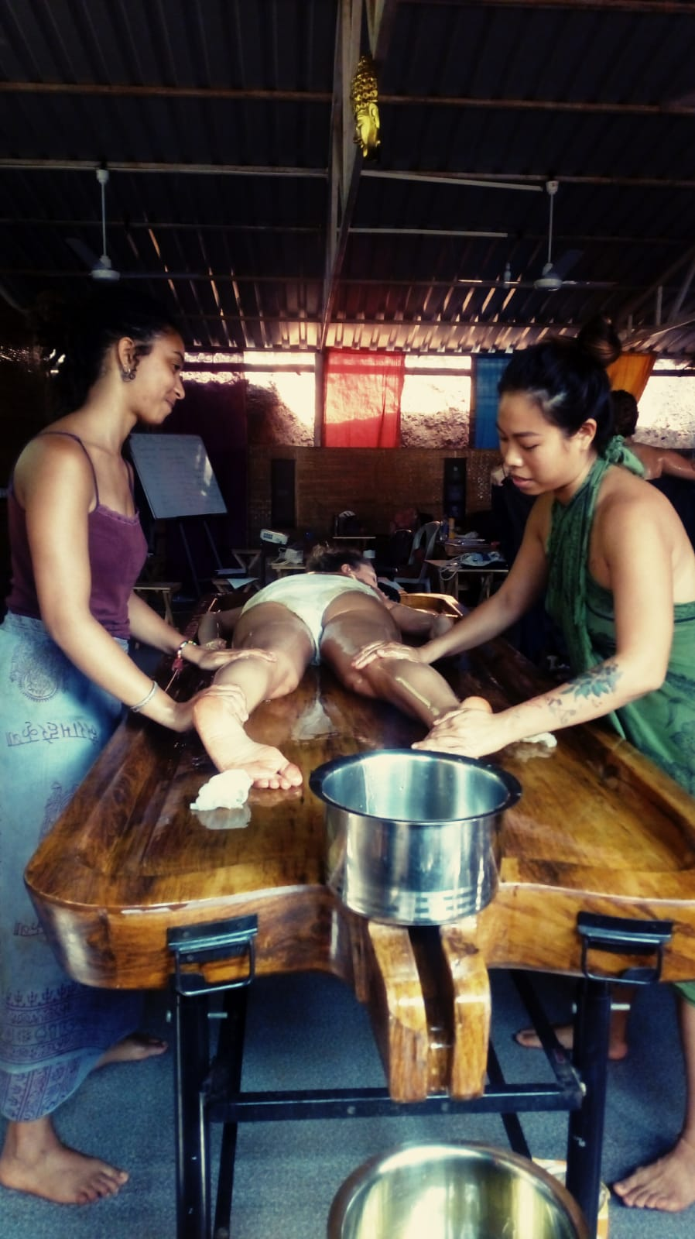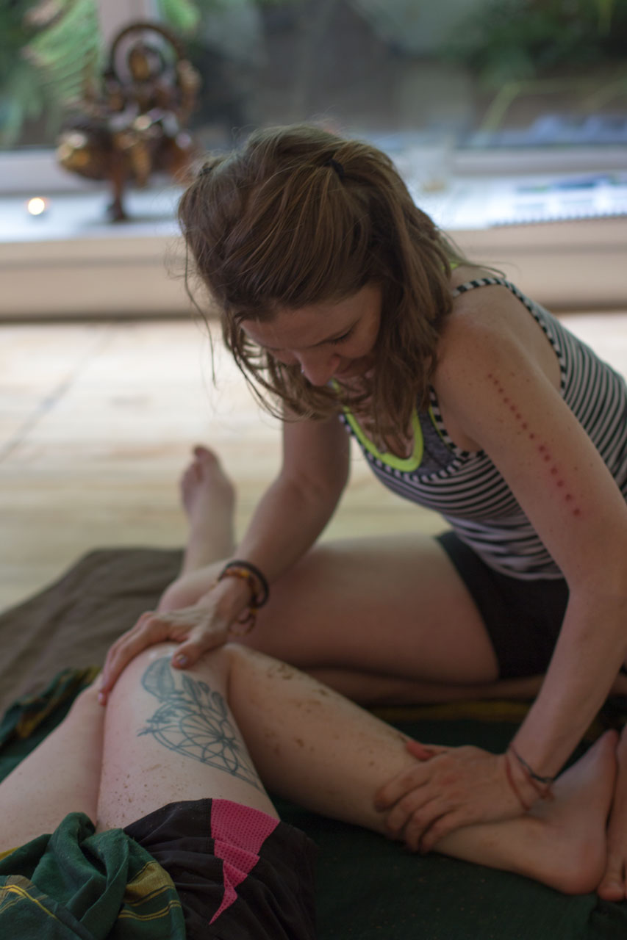

Similarities

Benefits
Contraindications
DIFFERENCES
- WHICH PART OF THE BODY GET MASSAGED?

There is set sequence massaging There is a flexibly set sequence massaging
- the body only (called abhyanga) - the whole body included face, feet, hands
- the shoulder/neck/head only (called Indian head and shoulder
massage)
- the face only (called face massage)
But we always discuss your needs regardless which technique you choose and alter them.

- WHAT TO WEAR
Only your underwear. Make sure you do not wear the most beautiful, expensive one as it might get oily! :o)

- PROPS USED
- Abhyanga – massage bed Massage mattress on the floor
- Indian head and shoulder massage - chair
- Face massage – anything you can lay on

OILS:
Seasame seed oil or coconut oil Sesame seed oil + Calamus powder*
(*More about calamus powder please check:
https://www.anantamassage.com/buy-calamus-powder-ayurvedic-yoga-massage)

- LOCATIONS
- Abhyanga – in Hanwell (W7)
(unless you have massage bed at home) Hanwell or your home
- Indian head and shoulder massage – Hanwell or your home
- Face massage - Hanwell or your home

Aurvedic yoga massage

